IMAGE SUBTITLE

From Sylke Becker
Phone +49 69 756081-33
E-Mail s.becker@vdw.de

Press release images
Precision grinding guarantees smooth running in electric drives

((01_Thomas_Breith_Liebherr-Verzahntechnik.jpg))
“Compared to conventional combustion engine gearboxes, the gearing in e-drives generally needs to fulfil a more extensive and stricter range of surface quality requirements,” says Thomas Breith, Head of Product Management at Liebherr-Verzahntechnik GmbH

Photo: Liebherr-Verzahntechnik

((02_Liebherr_Gear_Solution.jpg))
Generating grinding of an output gear for an electric drive with dressing-free CBN. Dressing-free CBN grinding worms from Liebherr-Verzahntechnik GmbH offer a number of advantages: high process stability due to their long tool life, avoidance of error sources during dressing, simple tool handling and significantly reduced measuring and testing effort. The very finest surfaces – with an Rz roughness value of less than three micrometers – can be produced.

Photo: Liebherr-Verzahntechnik

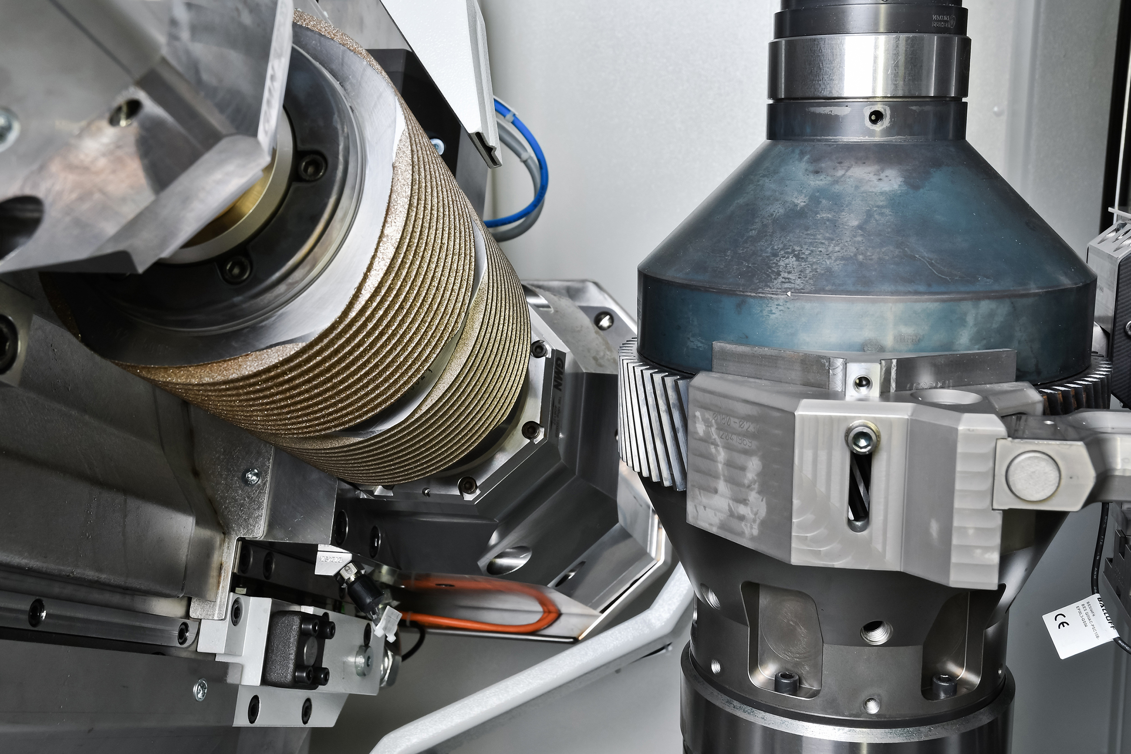

((03_Liebherr_E-Bike.jpg))
A cyclist out in the countryside on an e-bike would rather hear the birds singing than obtrusive noises from the bike's drive unit. Smooth running is important in electric vehicles. This is a technical challenge that requires perfectly polished components.

Photo: Liebherr-Verzahntechnik
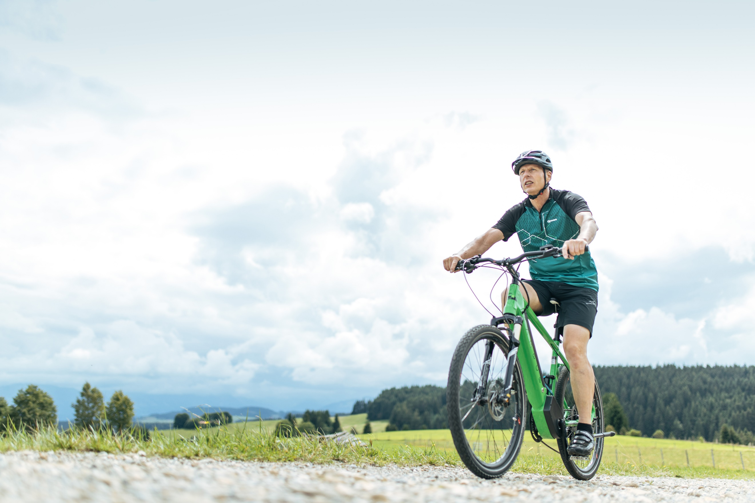

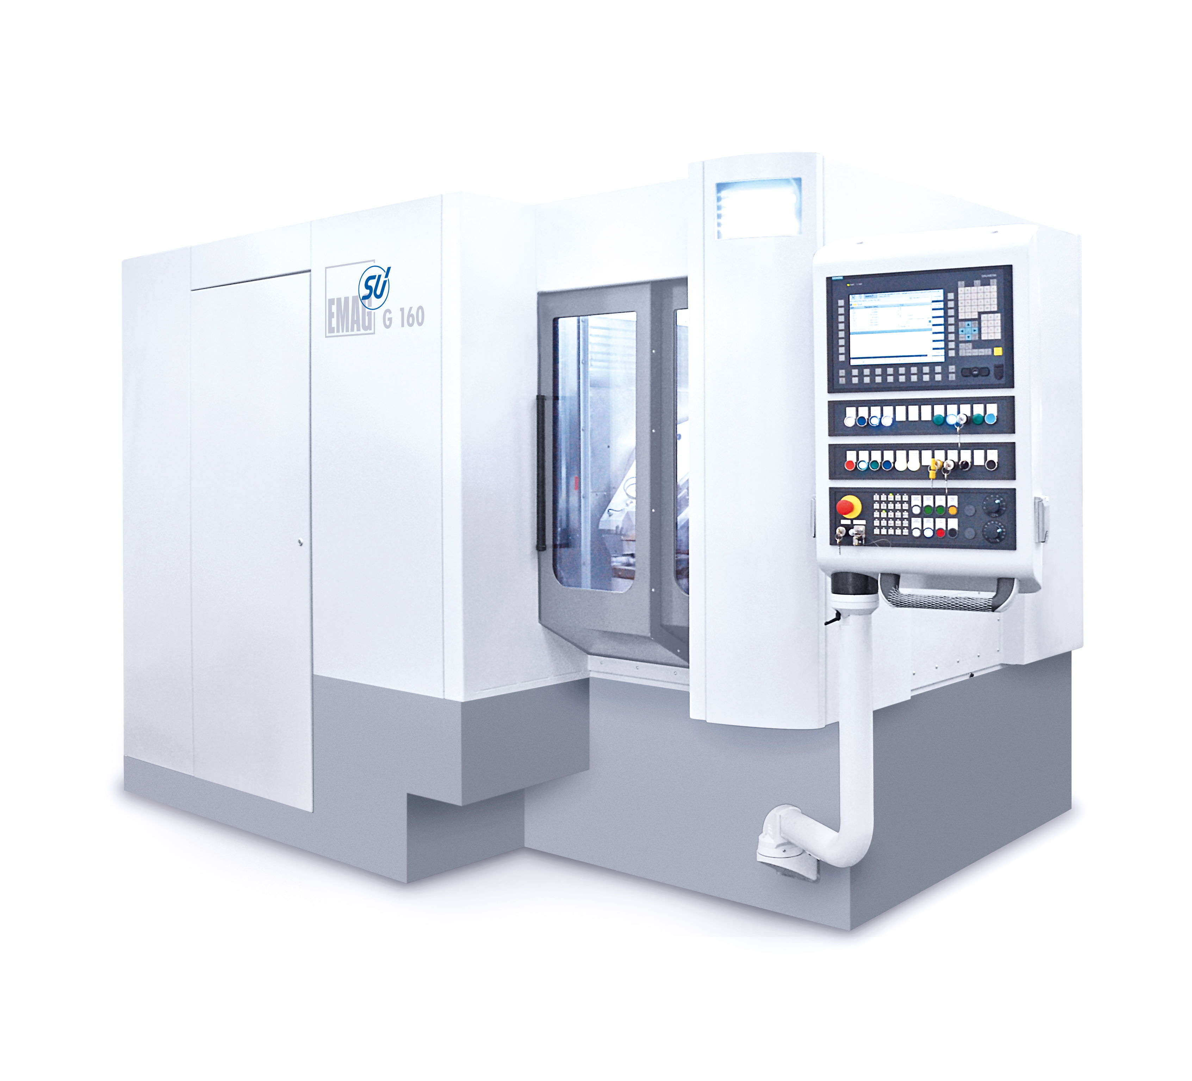
((04_EMAG_G160.jpg))
Machine manufacturer Emag GmbH & Co. KG offers the G 160 machine model for gear grinding. The axis concept creates the perfect surfaces that are crucial in electric vehicles. The decisive factor here is that the G 160 has no tangential axis; instead the existing Y and Z axes generate a "virtual" tangential axis through simultaneous movement.

Photo: Emag

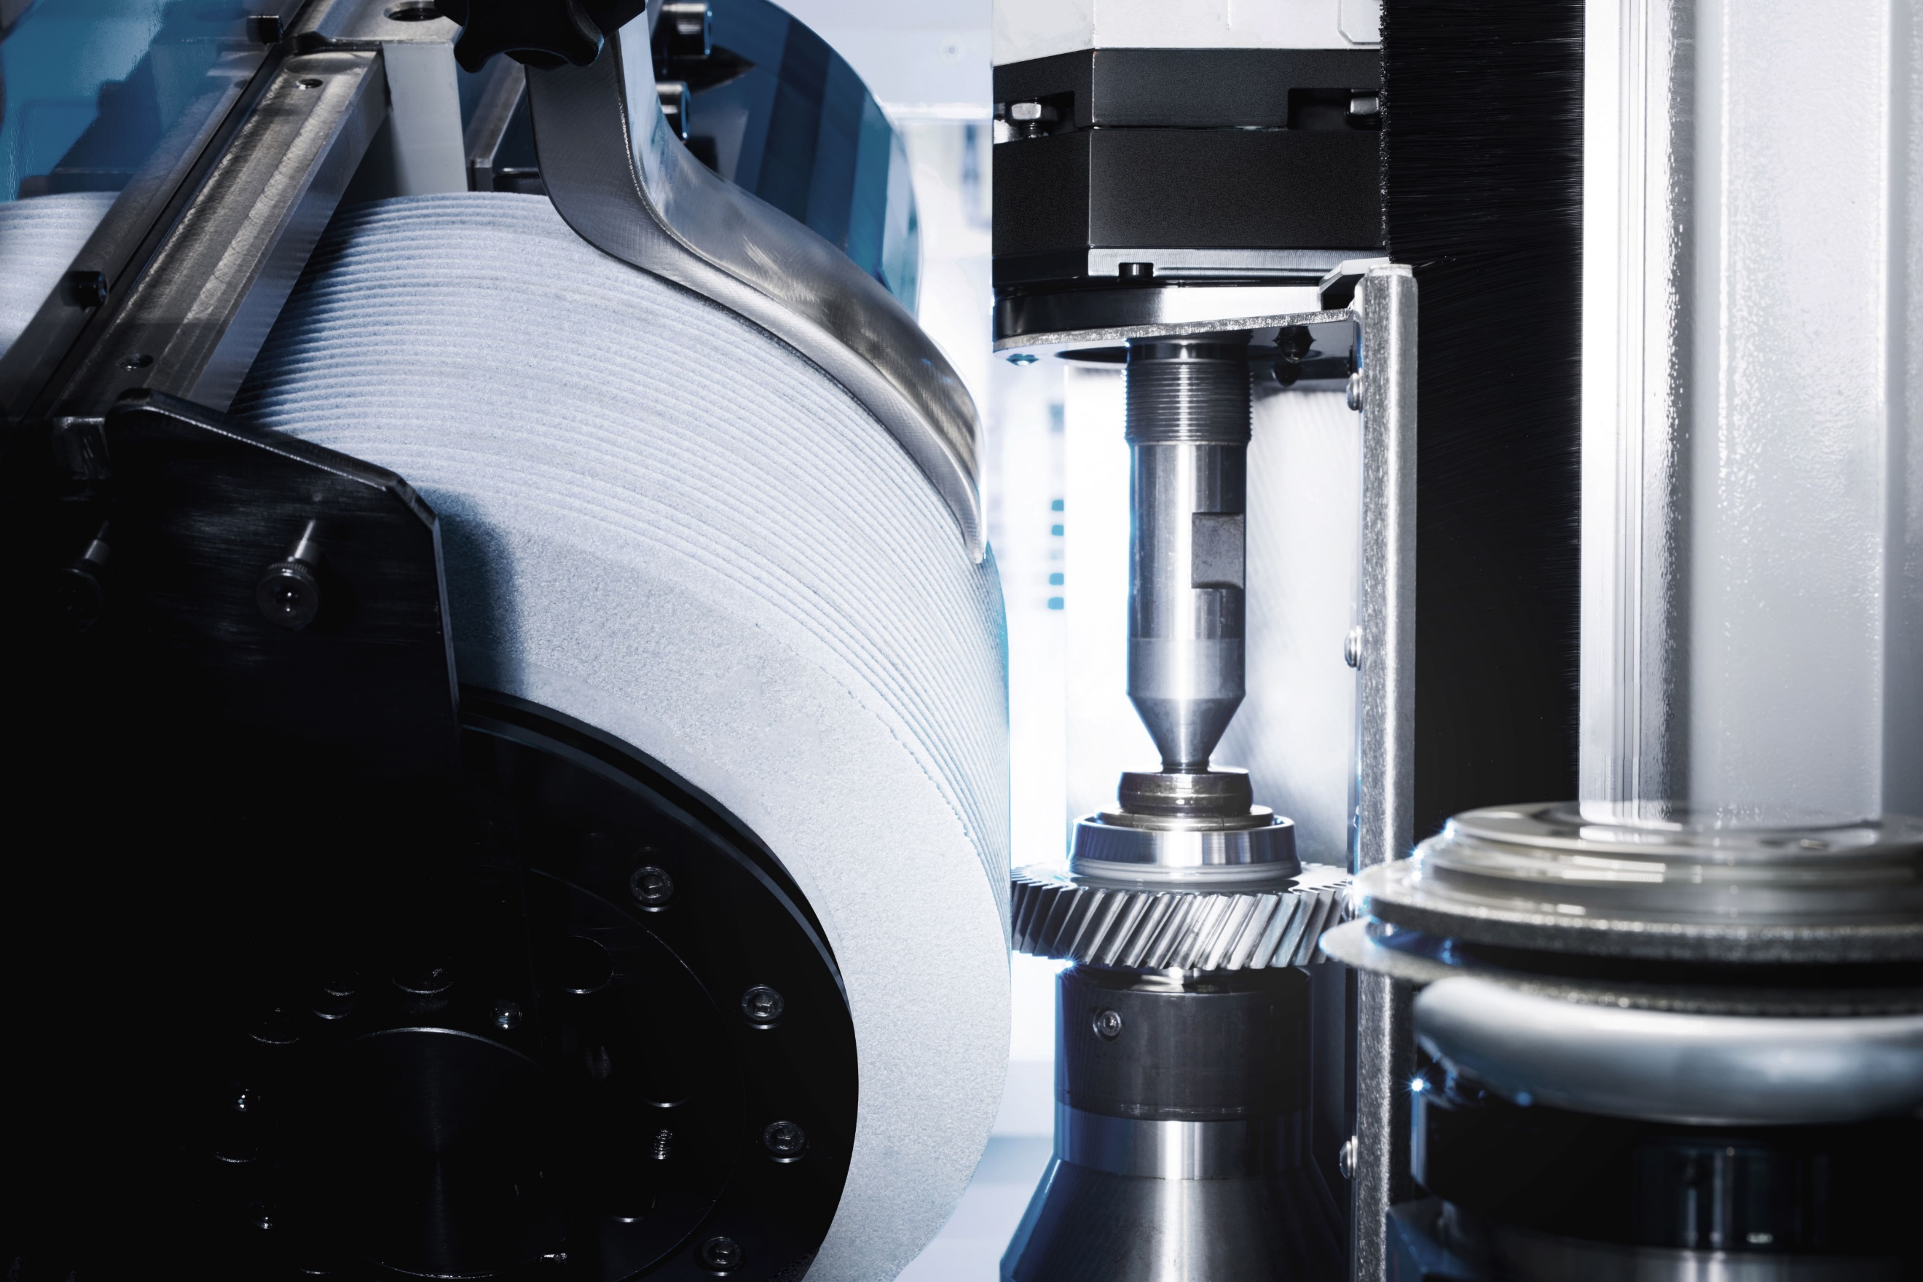
((05_EMAG_Schleifloesung_Verzahnung.jpg))
The machine manufacturer Emag GmbH & Co. KG offers particularly precise grinding solutions for use in electric vehicles. The technology guarantees maximum surface quality down to the micrometer range and also ensures that no obtrusive running noises arise in the gearing components.

Photo: Emag

